CHAPTER ONE

INTRODUCTION

**1.1 BACKGROUND OF THE STUDY**

Nowadays education plays a great role in development of any country. Many of education organizations try to increase education quality. One of the aspects of this improvement is managing of school resources.

However, “Talbelu secondary school Ibeto” currently uses annual method to process student registration, generate student admission number, recording result of student and staff information management.

The profound effect of the application of computers in management of school activities cannot be over emphasized, computer has been used to process student admission and registration, as well as their academic processes. Beside that the result of the student when fully computerized will be easier and quicker to process. The e-portal will be able to effectively and efficiently administer and manage the information in “Talbelu secondary school”.

Despite the main technological advancement in information technology over the past few decades, the typical management information at “Talbelu Secondary School Ibeto” has virtually remained unchanged. Any improvement in management could make significant contribution to improve the management system in the school. Currently this school does not use any kind of application system to assist in their daily activities, as is common in some schools and in developed countries. Hence the best step is to introduce an information management system for the school.

**1.2 MOTIVATION**

The importance of school education lies in the fact that the children of today will become adult citizens of tomorrow. The growth and future of our country highly depends upon the quality of the present school education system. And in a good school the primary objective is to stimulate interest and curiosity in the students and provide all possible facilities for headmasters, teachers and parents to achieve the desired goal which is a better and easier educational way for students. So, the motivation for our project came from that it has been made for that purpose, and for trying hardly to achieve all the previous goals. The new system will bring about efficient and effective academic information system. The concise documentation of student’s details will tremendously to improve timely decision support

**1.3 PURPOSE OF THE STUDY**

The project is aimed at designing a school management system for Talbelu secondary school. The functionalities are related to normal existing websites, this entails;

1. To describe the tools required to design and implement a functional Apache HTTP web, HTTP web server and MYSQL relational database server for “Talbelu secondary school”.
2. To develop the system and procedure for the school to ensure that end-users are provided with equisetic tools and data that are cost effective and easily accessible.
3. To facilitate grades entry process for students by teachers.
4. To facilitate distribution process of courses and classes for teachers.
5. To enable parent, track their student’s grades and ensure proper documentation of records.
   1. **METHODOLOGY**

The research methodology used in this research work include includes documentation, the internet, textbooks and direct observation on the existing system. These methods provide reliable information and required knowledge for this research and proper guidance; HTML and CSS will be employed in designing the front-end, Python and JavaScript technology will be used as the scripting language; MySQL will be used as the database (backend), Django will be used as the local server. The combination of the above will help build a very robust platform that will be useful, fast and handy for the dissemination of useful information on troubleshooting.

**1.5 THE SCOPE OF THE STUDY**

This project work is centered on developing a website with the intention of eliminating the barriers to free dissemination and access to information that pertains to the Talbelu Secondary School through an online website. The website will focus on the student together with its accompanying web interface, student’s registration, student to classes allocation, subject to teacher allocation, academic result and others that had been mentioned in the background of this proposal. Data not withstanding of its size cannot be too large to process. However, a guided approach is adopted to stay within limits for easy comprehension.

The people that are expected to fully utilize this website are:

• Teacher

• Students

**1.6 EXPECTED CONTRIBUTION TO KNOWLEDGE**

The project would go a long way in fostering good perception of the information age in our various institutions and individual organization thereby breaking the ugly bone of continuous use of manual and archaic systems. It fosters on the in-depth, principles, rules and protocols of coding, scripting and hosting of database driven web pages. It will also help in making the processing of information as well as in the reporting feedback, enlighten our young database developers and provide for them a springboard. It also stirs and gives focus to schools on the facilities obtained in the use of modern record keeping system of communication. The future researchers could gain knowledge from the study on the benefits, advantages and disadvantages, impact of developing website which they may apply to their research in the future.

**1.7 DEFINITION OF TERMS**

**Academic standing**: A student's academic progress in a program and the outcomes of the formal review of progress undertaken as part of the University's academic review process.

**Website**: also written as web site, collection of related web pages, including multimedia content, typically identified with a common domain name, and published on at least one web server. (thefreedictionary.com 2011).

**Hypertext Markup Language (HTML):** HTML (Hypertext Markup Language) is a text-based approach to describing how content contained within an HTML file is structured. This markup tells a web browser how to display the text, images and other forms of multimedia on a webpage (thefreedictionary.com 2011).

**Common Gateway Interface (CGI):** The common gateway interface (CGI) is a standard way for a Web server to pass a Web user's request to an application program and to receive data back to forward to the user (thefreedictionary.com 2011).

**Information**: is any kind of event that affects the state of a dynamic system.

**Database**: it is a system intended to organize, store, and retrieve large amounts of data easily.

**Django:** Django is a free and open-source cross-platform web server solution stack package that encourages pragmatic design.

**CHAPTER TWO**

**LITERATURE REVIEW**

**2.1 PREAMBLE**

The purpose of this chapter is to show the connection between what is presented for study with the existing knowledge, previous studies, or contemporary practice with relevant citation of other scholars work with respect to the problem.

**2.2 REVIEW OF RELATED LITERATURE**

The most initial school administrative computer applications started its development in the late 1970s. In the early1980s, several loose, non-integrated clerical and administrative applications were developed but these applications limited the possibilities for management support as the relationships among data could not be analyzed. (Visscher, 2019).

During the initial stages, the main purpose of software development and usage was to improve the efficiency of schools and offices activities. The use of computers and technologies in educational institutes was mainly to store student’s and personnel’s data (Carnoy, 2018).

The value of management information was recognized during the integration stages. As a result, many projects were initiated by the governments in many developed countries that provided the stimulus to enter a higher development stage. These projects were directed toward the production of better school information systems which meant increased school efficiency and effectiveness. The focus was the development of a standard system for as many schools as possible with maximum flexibility. The professional approach to systems design was not widespread at this time. In the 1990s, the emphasis on using ICT to collect educational data and to improve the administration of educational systems began to increase in the developing countries. (Visscher, 2019)

(Visscher, 2019) believes that school management information system can provide administrators and teachers with the information required for informed planning, policy-making, and evaluation.

(Gurr, 2020) claimed that school management information system has changed school management in the areas of leadership, decision making, workload, human resource management, communication, responsibility, and planning.

These systems can assist the school manager in determining the aims of the school, formulating strategic plans, distributing resources, and evaluating staff performance as well as organizational success (Telem, et al., 2019).

Several surveys have been designed in recent years to gather information on the extent to which schools are developing the capacity to integrate ICT into learning, teaching, and management processes. A steady increase in the number of computers and other technologies over time has been evident in the literature, with most schools achieving the baseline targets for computer-to-pupil ratios (Condie, 2017).

This finding, to a degree, masks considerable variation within and across schools with regard to regular access to reliable technologies and broadband connectivity (Condie, 2017).

(Demir, 2006) surveyed 98 elementary school principals in Turkey to explore their perceptions about School management and their use in primary/secondary schools’ management. The study indicated that although technologic infrastructures of elementary schools in were insufficient, School management information Systems had an important contribution to school management.

He also suggested that school managers should be encouraged to use information systems and they must believe that data are valuable sources for decision making and that the school management information system backs up the implementation of educational reforms. Information systems support not only information process but also innovations (Haag et al, 2018).

As being adaptable to changes, these systems are helpful to cope with the demands for change. Therefore, school management systems improve the adaptation of the school to the environment. They enable the school to comprehend and define inner and outer information transfer. Thereby, school management both meets the demands and expectations of its inner (teacher, student) and outer members; and ensures that school activities are arranged accurately and on time Pegler (2022). Introduction of school management system to school have caused significant changes in roles and working styles of managers (Telem, et al, 2019).

School management system have changed school management in the areas of leadership, decision making, workload, human resource management, communication, responsibility and planning (Gurr, 2020). Strategically school management system helps the manager in determining the aims of the school, making long term plans, distributing resources, and forming educational methods of future, determining performances of teachers and success of the school. In this way, school management systems can also be used as a tool to initiate and use educational leadership (Telem, et al, 2019).

School managers can make more efficient decisions when they get correct and up-to-date information by school management systems (Christopher, 2018).

Decision making is the heart of educational management. Daily, problematic conditions that require decision making are based on the complicated and unexpected nature of school environment. For this reason, as a problem solver, the educational manager has to gather and analyze information continuously (Perez & Uline, 2018).

In addition, managers have been required to make more decisions in short times because of the increasing expectations from the educational system (Christopher, 2018).

Moreover, decision making has been faster, more frequent and more complicated in schools of today. In order to make decisions under these conditions, gathering data that is continuous, up-to-date and that can be accessed on time and analyzing and using this data is an obligation (Telem, et al, 2019).

Success of school development studies are mostly based on data based decision making. However, school managers are not able to use the data efficiently in this aspect. Researches in various countries confirm that school management systems increase managerial effectiveness (Gentry, 2015).

After studies done with American school managers, (Hedberg, et al, 1992), stated that efficiency has increased in decision making at schools where school management systems are used. In his study where he examined effects of school management systems on working of primary school managers in Australia, managers stated that use of school management systems has introduced them with uses of technologies and the facilities, lessened their workload and made management process more efficient, helped them use time more efficiently, made teachers feel themselves more important, made them and the teachers wish to improve themselves more, made important changes in education and teaching, and increased the quality of in-school communication.

In their study with school managers, (Telem, et al, 2019), found that school managers believed that school management systems lead to important changes at school. According to school managers, this application has increased school standards, helped decisions on the level of control and strategy, increased the quality of teaching programs, facilitated student-teacher interaction, increased the coordination between teachers, and facilitated systematic and continuous information transfer to parents.

Lastly, (Anderson and Dexter 2016) in their studies determined that technology leadership of school managers is more important than background in the efficient use of technology at schools.

According to (Filter, 2016), education is one of the bases of shaping human being existed along before organized schools were ever thought of Education is not something different from life and society but is in fact the process of learning to live as a useful and acceptable member of the community. It is important to note that formal education, as provide in schools, is one of the least permanent of the forces which influence people. Both the traditional and modern system of education is full categorized as agent of socialization and economic development. It was stated by filter that “One of the problems our schools suffer today is inadequate attention on the students and improper evaluation of student’s performance”.

According to (Haag, S. et al, 2018), evaluation is a process to which most students grudgingly submit. It is rarely a process they seek and enjoy. Students in the developed nations are formally evaluated at appropriate intervals during the curriculum to assess and document satisfactory progress and achievement of learning objectives and prescribed competencies. These evaluations occur on a regular basis at scheduled times during each course. Depending on the learning and competency outcome objectives, these evaluations are designed to assess the level of knowledge, problem-solving skills, psychomotor and clinical competencies, and behavioral performances of students during each course and/or fieldwork experience. Evaluation methods vary, depending on the course or experiential learning opportunity, and may include formal examinations, written essays, portfolio assignments, design and fabrication projects, psychomotor skills check, or other methods of determining the extent to which each student has mastered the course content and skill competencies.

Student performance in formal examinations is graded on a numerical/alphabetical system using a standard grading scale, which is based on the policy of the school/nation. Students are customarily provided with feedback and grade reports after each examination summarizing their performance on each test items. Students will be required to participate in competency-based evaluations at various intervals throughout their academic tenure. (Robinson, 2018)

* 1. **MANUAL RESULT PROCESSING**

Sometimes the delay in declaration of results cause heavy losses to the students as generally they cannot join further studies or appear in competitive exams because of the non-availability of examination result in time. Some of the limitations of the existing system, though not comprehensive, are as follows:

1. **Repetition of Work:** There is repetition of work in the existing system because the same data is recorded in different record peppers/books which may be cannot retrieved at the require time. This leads to data duplications as well as huge money is spent by the school to purchase papers. In existing system, managing of students’ record is very tedious. Retrieval of students’ records through manual registers, maintaining of records and data reconciliation etc. are very time consuming.
2. **Time consumption:** It is taken them (teacher) much time before they compiled the results especially if the number of the student is much.
3. **Errors in computations:** of course, the manual system cannot be free of human errors.
4. **Tempering of student Records:** In manual system, there are a lot of chances to tempered with students’ records specially when the teacher tries to update it. for this, the student too may alter the report sheet before taken to their parents/guardians. This leads to unfair practices and it mars the credibility of the school.

A number of problems associated with student academic record management include improper storage, late release of students’ results, inaccuracy due to manual and tedious calculation and retrieval difficulties/inefficiency etc.

**2.4 ANALYSIS OF THE EXISTING SYSTEM**

In Talbelu Secondary School, records are being keeping manually on papers for both the students and the staff which are highly unsecured and they can be destroyed or altered easily. Furthermore, all the processes of those records are also highly time consuming. Likewise, the result computation and compilation are very tedious and cumbersome task that is associated with a lot human error.

According to Muhammad Wakil (principal) it is taken them (class teacher) much time before they process the students’ tests, assignments and exams to produce report for a class. This is one of the reasons why students’ results are not given to them on the specified time (end of term). This difficult task affects the teachers’ preparations against next term since they covered their work very late. Hence, this process continued as the number of students are increasing. These make the teachers unhappy with their work. Imagine a teacher compiling just 30 students results and the stress the teacher has to undergo. The teacher gets busy calculating (addition and division) each student’s test and exam scores. For every student, the teacher will add what the student scored in assignment, test and exam to get the total for that subject, assume the subject is Mathematics; the teacher will repeat it for the rest subjects offered by the student just to get all the total scores for each subject. To get the average score for this student, the teacher will have to add all the total scores for each subject offered and then divide by total number of subjects offered by the student. The same process is repeated for the remaining 29 students. The teacher will also enter the record into each student “Report Card” then create a broad sheet called Master Sheet for all the students’ records for future references. This is stressful and time consuming, in order to manage this computation and to make teachers less stressful, make their job enjoyable and to make them direct their attention on teaching is very easy with computerized system. On the other hand, imagine one person processing 100 or more students result from various classes with little effort of just entering students’ scores as soon as they are entered properly the results generated automatically for printing no matter how large the size of the students in a class/school. In each term, the system generates test and exam scores sheet with students’ names arranged accordingly with columns/rows created for each subject score entering. This is given to the person in charge of the system to fill in scores after the test or exam is conducted. The system can store test of students before they will write their terminal examination, the test will be retrieved later and to be added exam’s scores to generate the result with just a click on result generate button, the result will automatically be generated and appear on the screen to save or for printing.

**2.5** **THE PROPOSED SYSTEM**

The project is a contribution to all-important aspect of the computer age. It is to provide intelligent information to user engineers, technical personnel and any other person concerned with types of faults, analysis of faults, as maintenance's routine in microcomputers. He/she need to go to the background bringing of computers tells the present-day microcomputer. In our proposed system we have the provision for adding the details of the students by themselves. So, the overhead of the school authorities and the teachers is become less. Another advantage of the system is that it is very easy to edit the details of the student and delete a student when it found unnecessary. The marks of the student are added in the database and so students can also view the marks whenever they want.

Our proposed system has several advantages

* User friendly interface
* Fast access to database
* Less error
* More Storage Capacity
* Look and Feel Environment

**2.2** **DATA AND INFORMATION**

(Ugorji, 2016) is at the view that data and information are terms people use interchangeably in everyday speech, but they mean different thing.

Data are facts such as a Name, a Number etc while the term information is simply a processed data, that is when data is converted into a more useful or intelligent form.

**DATA**

Data is any sequence of one or more symbols; datum is a single symbol of data. Data requires interpretation to become information. Digital data is data that is represented using the binary number system of ones and zeros, instead of analogue representation. In modern computer systems, all data is digital. Data are individual facts, statistics, or items of information, often numeric. In a more technical sense, data are a set of values of qualitative or quantitative variables about one or more persons or objects, while a datum is a single value of a single variable. (Wikipedia contributors, 2022)

**INFORMATION**

Information is processed, organized and structured data. It provides context for data and enables decision making processes. For example, a single customer’s sale at a restaurant is data – this becomes information when the business is able to identify the most popular or least popular dish. Information is organized or classified data, which has some meaningful values for the receiver. Information is the processed data on which decisions and actions are based. (Wikipedia contributors, 2022)

**CHAPTER THREE**

**METHODOLOGY AND DESIGN**

**3.1 INTRODUCTION**

Methodology is a way of careful study or investigation especially in order to discover new fact or information, hence research methodology should be sound enough to make attainment of the set objectives possible with specific components such as methods of data collection and design. However, data which are collected for the purpose of research are known as primary data. Primary source for collecting data is used, because of the advantage that it extracts information directly from the original source. This chapter entails the System Modelling (Use case, activity and class diagrams) as well as the input/output specifications and system requirement for the design of this system.

**3.2 METHOD OF DATA COLLECTION**

It is crucial to acquire data and facts about the current system before implementing any system since one has to understand what is happening. In executing this research, three methods were employed.

1. Interview
2. Observation method.
3. Documentation

**3.2.1 INTERVIEW**

Interview is the most commonly used technique to collect information from the face-to-face interviews. The purpose of interview is to find, verify, clarify facts, motivate end-users involved, identify requirements and gather ideas and opinions. The role of interview includes interviewer who is system analyst and interviewee who are system owner or user. Interviewing technique needs good communication skills for interaction between system analyst and user. During my interview I contacted the head of the management in the person Muhammad Wakil and together with some staff of the school, the responds were positive and data was also being collected from the school management.

**3.2.2 OBSERVATION METHOD**

This strategy was used to collect information and data for this study by observing how the manual system functioned. Through close observation, the most obvious problems with the current system were found. The setting in which the observation is made can be changed in a variety of ways by using the observational method.

**3.2.3** **DOCUMENTATION**

A supplementary form of data acquisition is documentation. Journals, manuals, previous projects, newspapers, and other sources are used in this approach. This type of data collecting is employed because it provides a foundation for comparison with earlier research. This includes the internet, a tool for gathering data. The internet was fully utilized to find information on topics that seemed challenging or unclear.

**3.3 SYSTEM MODELLING**

A system model is a conceptual model that describes and represents a system as a result of system modelling. Any interaction between a group of components that work together to accomplish a single goal is referred to as a system. Visual models of the object-oriented software-intensive systems can be made using a set of graphic notation techniques that are part of the Unified Modeling Language, which is employed in this modern system design. Use case diagrams, class diagrams, and activity diagrams are among the UML diagrams used in this new design. A Unified Modelling Language (UML) is employed in this research project.

**3.3.1 USE CASE DIAGRAM**

In systems analysis, use cases diagrams are a powerful tool for identifying, delineating, and organizing system requirements. The use case diagrams show a variety of potential interactions between people and systems in a certain setting that are connected to a specific objective. Use cases are collections of interactions between systems and users. All system operations that are significant to the system's user are included in the use cases (Bittner, 2016).

A use case can be thought of as a collection of potential outcomes connected to a specific goal; in fact, the terms "use case" and "goal" are frequently used interchangeably. Use case diagrams are used to visually summarise a system's functionality in terms of its actors, their goals (represented as use cases), and any dependencies between those use cases.

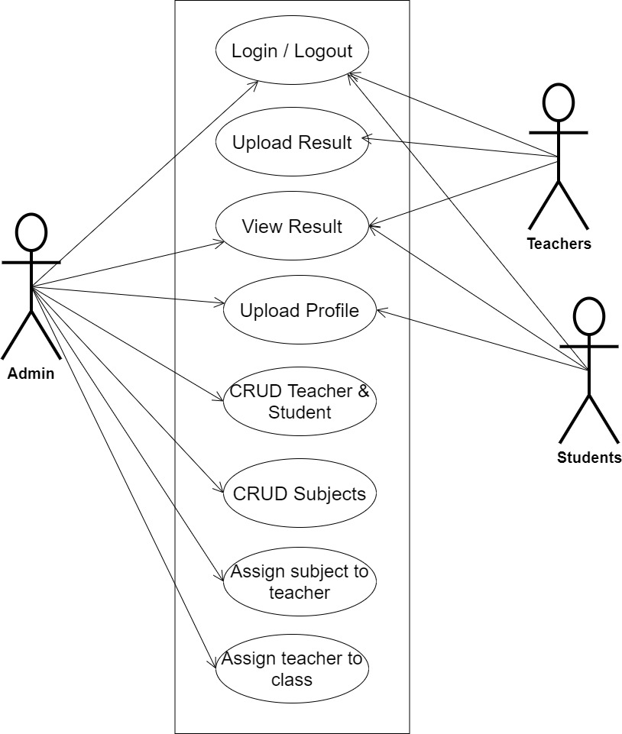

**Fig 3.1 System Use Case Diagram**

**3.3.2 CLASS DIAGRAM**

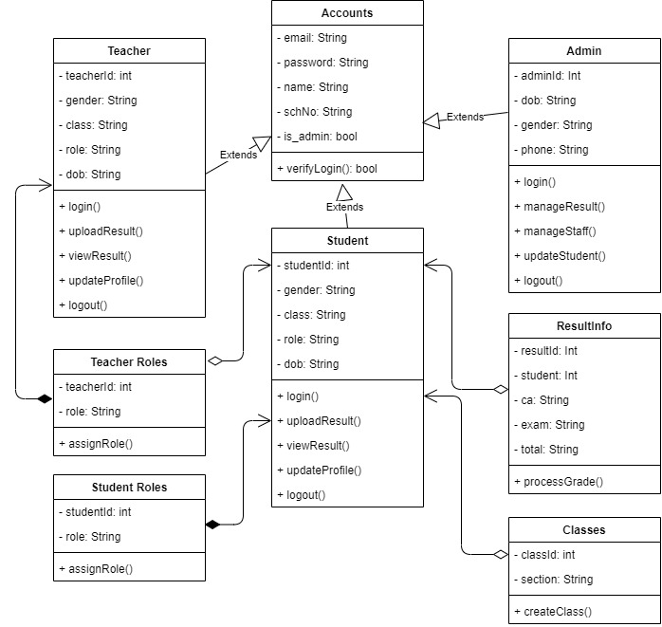The Unified Modeling Language (UML) class diagram is an implementation of an independent view of how the system interface will be, with each class having its own properties and illustrating how they interact to one another. Class diagrams use the rules established by the Unified Modeling Language to visually depict the static structure and composition of a specific system (UML). It is among the most frequently used UML diagram kinds. Class diagrams make it simpler to explain all of the classes, packages, and interfaces that make up a system as well as how these parts are connected to one another.

**Fig 3.2 System Class Diagram**

**3.3.3 Activity Diagram**

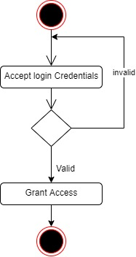

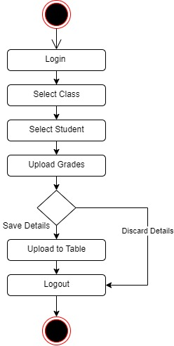

**Fig 3.3 Login Activity Diagram**

**Fig 3.4 Verify Result Activity Diagram**

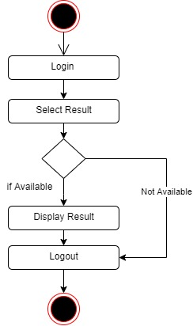

**Fig 3.5 Register Result Activity Diagram**

# **3.4 DATABASE DESIGN**

Input specification is the logical presentation of how data is stored in the computer’s memory. SQL standards are vital so that structured data will be uniform and independent of applications, the flexibility encountered in the use of the system as well as the ease in recalling and reading the data and ensuring applicability through the internet, the input specifications used in this project work are presented below:

1. Accounts Table: contains generic information about all system users (Admin, Staff, Student).
2. Teacher Table: contains detailed information about every teacher.
3. Student Table: contains detailed information about every student.
4. Admin Table: contains detailed information about every admin.
5. Result Table: contains needed information for processing students results.

**Table 3.1 Account Table input specification table**

|  |  |  |  |
| --- | --- | --- | --- |
| **FIELD NAME** | **DATA TYPE** | **LENGTH** | **DESCRIPTION** |
| Email | String | 150 | Email for login (case sensitive) |
| Password | String | 150 | Access Code (case sensitive) |
| name | String | 150 | Full name of the user |
| schNo | String | 10 | Unique string to identify users |
| is_admin | Boolean | 1 | Key to identify admin |
| acct_id | String | 64 | A unique string for identifying users |

**Primary key:** acct_id

**Table 3.2 Teacher Table input specification table**

|  |  |  |  |
| --- | --- | --- | --- |
| **FIELD NAME** | **DATA TYPE** | **LENGTH** | **DESCRIPTION** |
| gender | String | 10 | Gender of the teacher |
| class | String | 150 | Class assigned to the teacher |
| role | String | 150 | Role assigned to the teacher |
| dob | Boolean | 1 | Date of birth of the teacher |
| teacher_id | int | 10 | A unique number for identifying student |

**Primary key:** teacher_id

**Table 3.3 Student Table input specification table**

|  |  |  |  |
| --- | --- | --- | --- |
| **FIELD NAME** | **DATA TYPE** | **LENGTH** | **DESCRIPTION** |
| gender | String | 10 | Gender of the student |
| class | String | 150 | Class assigned to the student |
| role | String | 150 | Role assigned to the student |
| dob | Boolean | 1 | Date of birth of the student |
| student_id | int | 10 | A unique number for identifying student |

**Primary key:** student_id

**Table 3.4 Admin Table input specification table**

|  |  |  |  |
| --- | --- | --- | --- |
| **FIELD NAME** | **DATA TYPE** | **LENGTH** | **DESCRIPTION** |
| gender | String | 10 | Gender of the admin |
| phone | String | 14 | Admin phone number |
| dob | Boolean | 1 | Date of birth of the admin |
| admin_id | int | 10 | A unique number for identifying admin |

**Primary key:** admin_id

**TABLE 3.5 Result Input Specification Table**

|  |  |  |  |
| --- | --- | --- | --- |
| **Field NAME** | **DATA TYPE** | **FIELD SIZE** | **DESCRIPTION** |
| Student_id | int | 10 | A unique number for identifying results |
| Ca | String | 10 | Student continuous assessment score |
| exam | String | 10 | Student exam score |
| total | String | 10 | Student total score |
| Result_id | int | 1 | A unique number for identifying results |

**PRIMARY KEY:** Result_id

# **3.5 OUTPUT DESIGN**

This declares and show the result obtained from the input specified. The output product by the automated system depends on the input. Below is the output specification.

**Table 3.5.1 Account Table**

|  |  |  |  |  |  |
| --- | --- | --- | --- | --- | --- |
| **Email** | **Password** | **Is_Admin** | **Acct_id** | **Name** | **SchNo** |
| XXXX | XXXX | XXXX | XXXX | XXXX | XXXX |
| XXXX | XXXX | XXXX | XXXX | XXXX | XXXX |
| XXXX | XXXX | XXXX | XXXX | XXXX | XXXX |
| XXXX | XXXX | XXXX | XXXX | XXXX | XXXX |

**Table 3.5.2 Teacher Table**

|  |  |  |  |  |
| --- | --- | --- | --- | --- |
| **Teacher_id** | **Gender** | **Class** | **Role** | **DOB** |
| XXXXX | XXXXX | XXXXXX | XXXXX | XXXXX |
| XXXXX | XXXXX | XXXXXX | XXXXX | XXXXX |
| XXXXX | XXXXX | XXXXXX | XXXXX | XXXXX |
| XXXXX | XXXXX | XXXXXX | XXXXX | XXXXX |

**Table 3.5.3 Student Table**

|  |  |  |  |  |
| --- | --- | --- | --- | --- |
| **Student_id** | **Gender** | **Class** | **Role** | **DOB** |
| XXXXX | XXXXX | XXXXXX | XXXXX | XXXXX |
| XXXXX | XXXXX | XXXXXX | XXXXX | XXXXX |
| XXXXX | XXXXX | XXXXXX | XXXXX | XXXXX |
| XXXXX | XXXXX | XXXXXX | XXXXX | XXXXX |

**Table 3.5.4 Admin Table**

|  |  |  |  |
| --- | --- | --- | --- |
| **Admin_id** | **Gender** | **Phone** | **DOB** |
| XXXXX | XXXXX | XXXXXX | XXXXX |
| XXXXX | XXXXX | XXXXXX | XXXXX |
| XXXXX | XXXXX | XXXXXX | XXXXX |
| XXXXX | XXXXX | XXXXXX | XXXXX |

**Table 3.5.5 Result Table**

|  |  |  |  |  |
| --- | --- | --- | --- | --- |
| **Result_id** | **Student_id** | **CA** | **Exam** | **Total** |
| XXXXX | XXXXX | XXXXXX | XXXXX | XXXXX |
| XXXXX | XXXXX | XXXXXX | XXXXX | XXXXX |
| XXXXX | XXXXX | XXXXXX | XXXXX | XXXXX |
| XXXXX | XXXXX | XXXXXX | XXXXX | XXXXX |

**3.6 INPUT AND USER INTERFACE DESIGN**

This displays the pictorial representation of the system interface, the interface is going to be designed in a way that it will be user friendly, responsive and attractive. It will also be well secured such that login will be required to access some level of contents. The designs are aided by a mid-fidelity wireframing tool called Draw.io

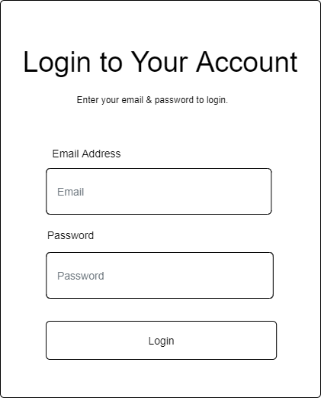

**Figure 3.6.1 User Login Page**

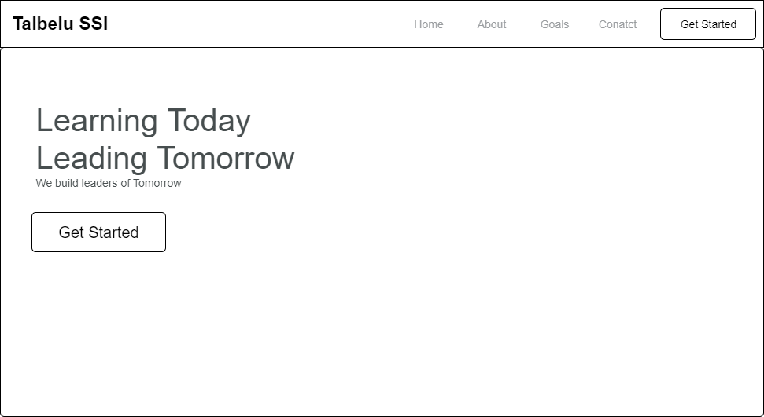

**Figure 3.6.2 Home page**

**3.7 SYSTEM REQUIREMENT**

All software system developed has a predetermined system requirement on which it has been designed to operate on for maximum performance. However, the system requirements are the minimum hardware and software required for a smooth operation of the system that is designed.

# **3.7.1 THE HARDWARE REQUIREMENT**

System Hardware Requirement;

1. Minimum of Intel Dual core processor.
2. Minimum of 1 GB of RAM (Random Access Memory).
3. Minimum of 250GB HDD (Hard Disk Drive).

# **3.7.2 SOFTWARE REQUIREMENT**

Software Requirement;

1. At least window 7 OS.
2. Browsers includes: Chrome, Firefox.
3. Python installation
4. Vs Code installation

**3.8 CHOICE OF PROGRAMMING LANGUAGE**

Various types of programming language exist that could have been used in writing this tutorial application but the choices of programming languages used involve HTML5, CSS3, JavaScript, Python (Django) and SQLite. The reasons for choosing these programming languages is that it is a web base applications and require web programming language and are as follows:

* **HTML** is the bedrock of Web Applications as it is the skeletal framework of a webpage. HTML5 is an updated version of it and it consist of various new tags that enable effective validation of forms and other functions that will assist JavaScript in some of it functions.
* **CSS3** is the latest version of the Cascading Style sheet that helps style the page and makes it display effectively on the screen of your device.
* **JavaScript** is a client-side scripting web language that is used for validation of forms and user inputs.
* **Python (Django)** is a server-side scripting language that enables communication between the server and web page. It usually works with any SQL database to deliver content from the server.

**CHAPTER FOUR**

**SYSTEM IMPLEMENTATION AND EVALUATION**

**4.1 PREAMBLE**

This chapter discusses a concise detail on how the system is to be implemented and sample of the working procedures of the proposed system. The chapter entails the program listing; sample outputs and steps for system installation for purpose of guiding new user on how to install the new System and also system testing changeovers.

**4.2 SYSTEM TESTING AND EVALUATION**

There are many reasons to conduct test for the developed system, because is only through testing that we can be able to analyze any problem in the new system and provide solutions to these problems This project employed both Unit and Integration testing to ensure effectiveness and efficiency of design and to ensure that the new system meets its required functionalities and is error-free.

**Unit Testing**

In this phase, individual units or single components of the system are tested independently to ensure that individual phases are working effectively without errors.

**Integration Testing**

In this phase, all the various components of the system are tested together using the actual data which will be submitted to the management for approval/acceptance.

**4.3 SYSTEM CONVERSION PLAN**

In preparation for the installation of a new system, the method of changeover to be adopted would have to be given serious consideration as whatever methods adopted would some extent determine the success of the new system. Possible conversion are direct, parallel and pilot methods. But the type of changeover we used during the implementation of this new system is parallel conversion. Parallel because it does require the ruling of both the new and current system side by side until the integrity of the new system has been proved beyond reasonable doubt before the current system can discarded completely.

**4.4 SYSTEM INSTALLATION**

After the system has been tested for some period of time, and found to be working smoothly as expected, the system will be ready for Installation and Implementation. For the new system to be installed successful the following requirement are needed. This is how to install the system

1. Make sure, pip, pipenv and Python 3 or greater is installed on the system.
2. Copy your project folder to any location of your choice.
3. Open project folder in Visual Studio Code
4. On the terminal run “pipenv install -r requirements.txt”
5. On the terminal run “python manage.py runserver”
6. Open any browser on the system example Chrome, Microsoft Edge, Mozilla Firefox
7. On the address bar, type <http://127.0.0.1> and press the enter key.

**4.5 SECURITY MEASURES**

Since the scope of the website is public, some of the information such as index page, login page e.t.c are available to anyone who visits the website. But some other information and functionalities are restricted to some and not all who visit the website. The restrictions are carried out by the use of passwords which gives different level of access to users. The highest level of access is held by the admin, followed by the staff then to the student with lesser access.

**4.6 Program Sample Outputs**

These describe and give the pictorial representation of the program or software; it shows and gives clear understanding of the design, and displays all the interfaces.

**4.6.1 Homepage**

This is the program homepage.

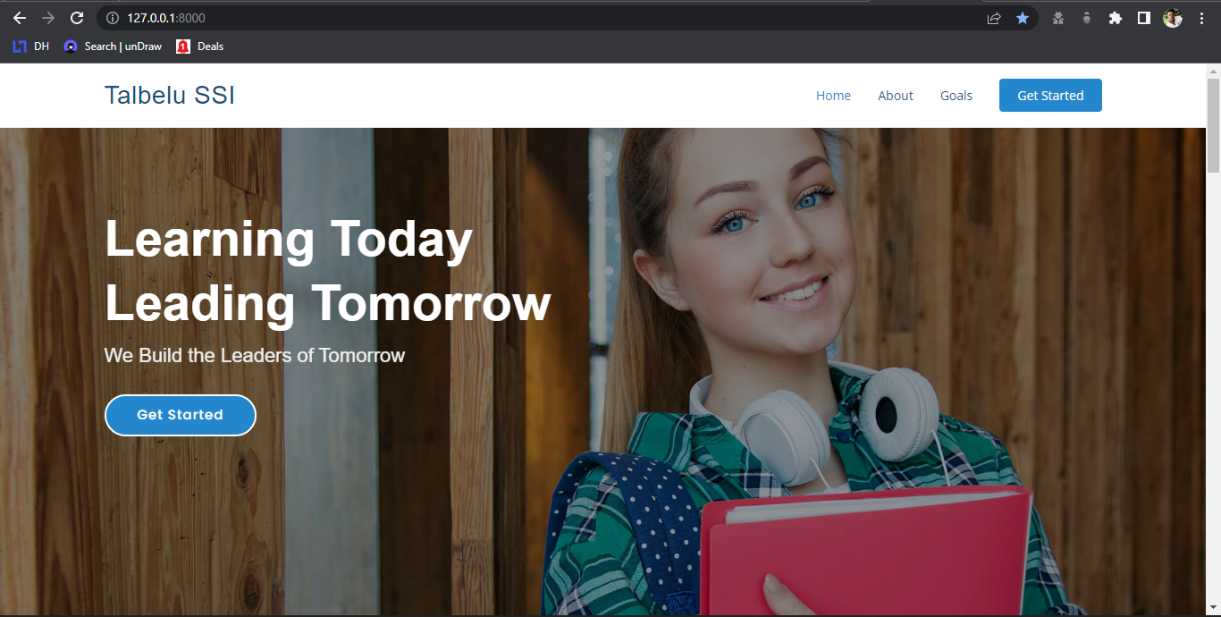

**Fig 4.6.1: Homepage**

**4.6.2 Login Page**

This is where the student, staff and admin can login by providing his right credentials.

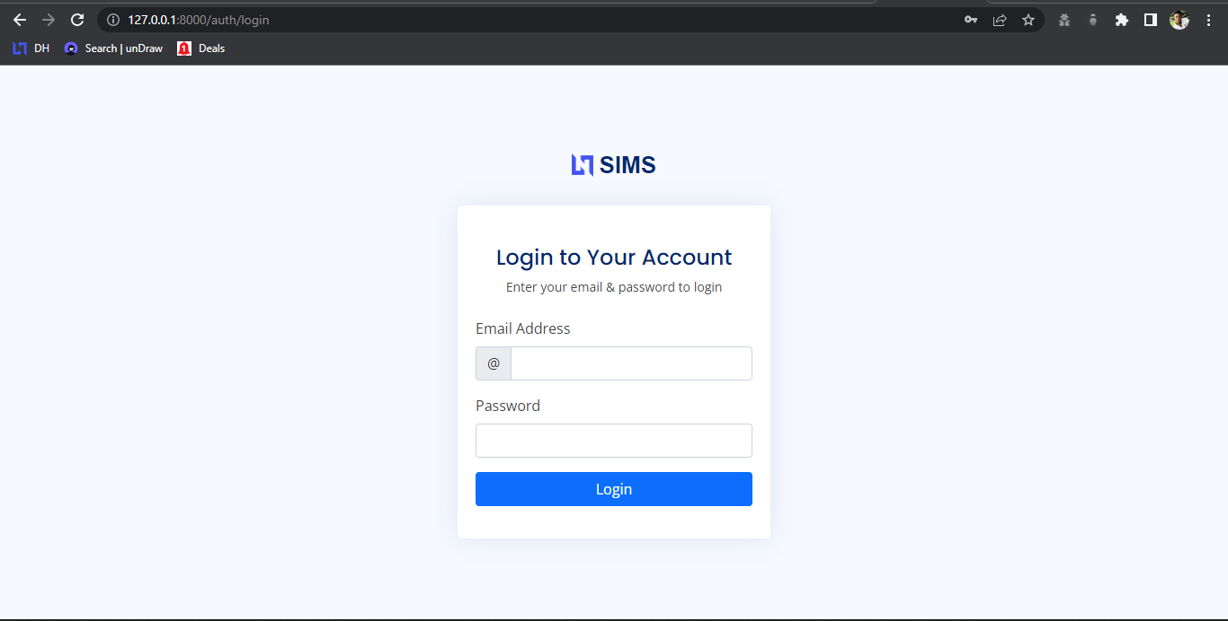

Fig 4.6.2: Login Page

**4.6.3 User Profile**

This is all user profile page where they can view, and change any of their profile information.

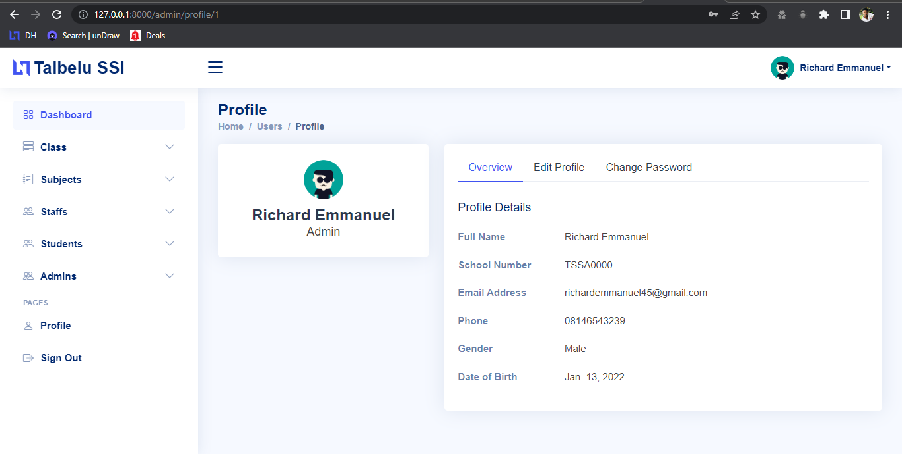

4.6.3 User Profile Page

**4.6.4 Create Student Accounts**

This is where admin can create students.

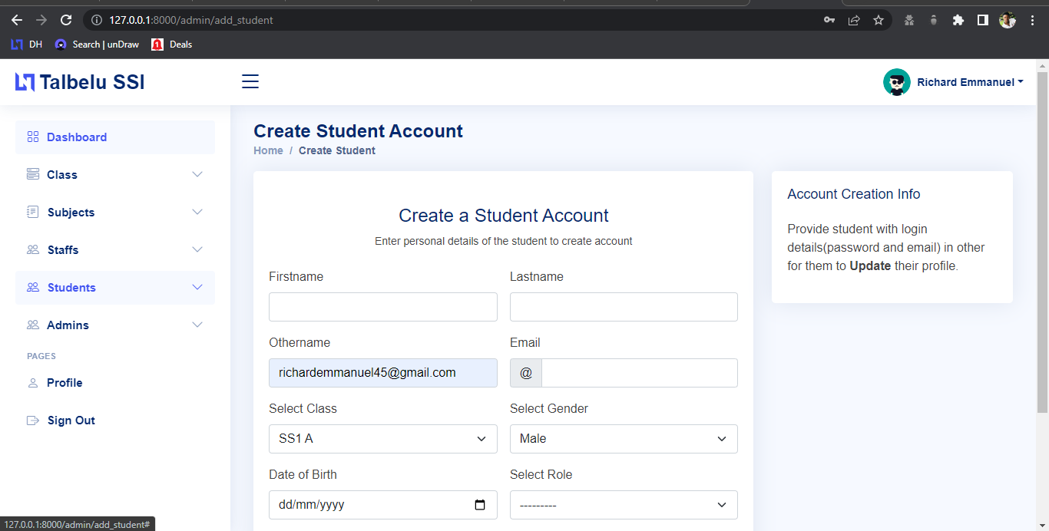

4.6.4 Create Student Accounts

**4.6.5 Admin Dashboard**

This is the admin homepage where admin have access to his or her dashboard.

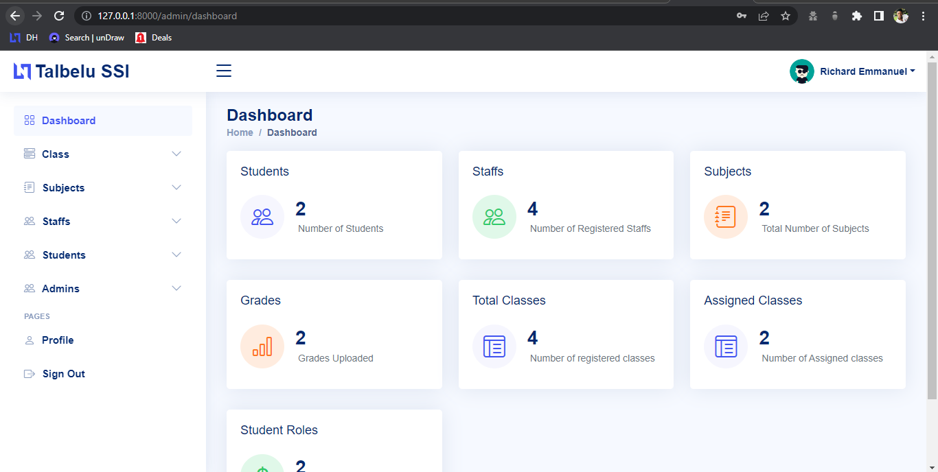

4.6.5 Admin Dashboard

**4.6.6 Teacher Dashboard**

This is the teacher homepage where teacher can have access to their dashboard.

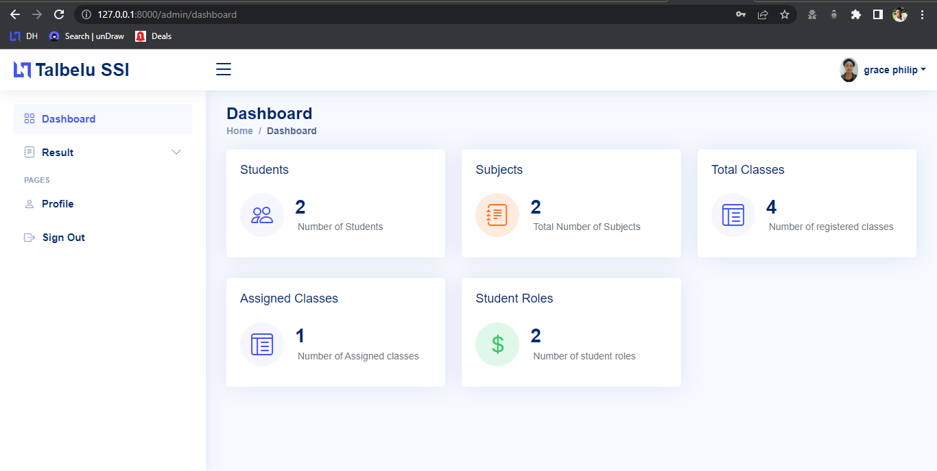

4.6.6 Teacher Dashboard

**4.6.7 Student Result**

This is the page where staff can view, edit, delete and print student result

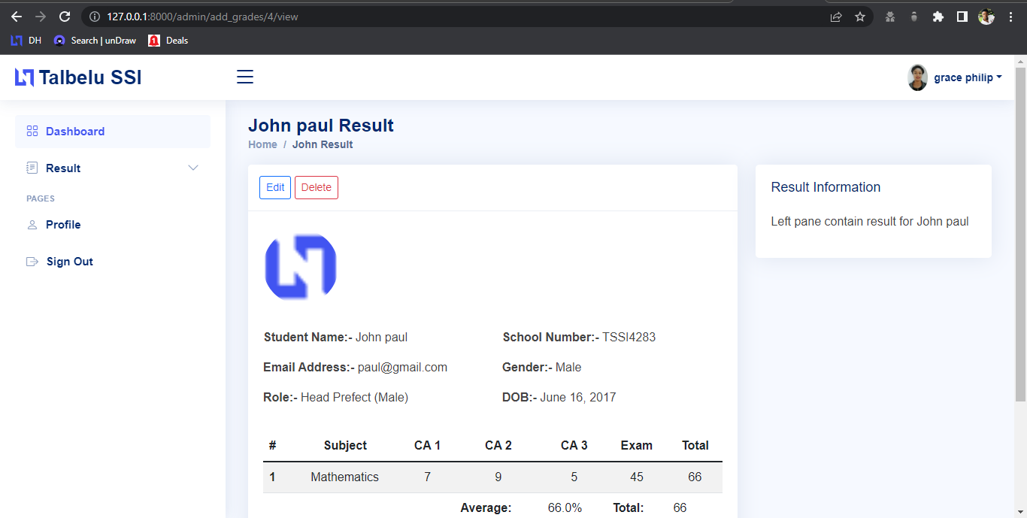

4.6.7 Available Building Materials

**CHAPTER FIVE**

**SUMMARY, CONCLUSION AND RECOMMENDATION**

**5.1 Summary**

In this project, we developed an automated school management system that facilitates some various activities taking place at Talbelu secondary school. This project was design to solve a problem that exist in the manual system of activities at Talbelu secondary school, this project also serves as a replacement for the outdated manual system used in school. The project was a success and the set-out goals of the project was achieved.

**5.2 Conclusion**

The project was conducted successfully and the purposed of the new system was also achieved. The new system is an improvement compared with to the existing system. The new system is user friendly and it has new features that will be helpful to the organization.

**5.3 Recommendation**

To enhance the efficiency of the system, in the following we have listed some recommendations and future works.

As education is central to development there should be a good facility to make stakeholders participate in school improvement programs and decision making. To facilitate easy information access to such bodies the web application could be further enhanced by incorporating additional reports required the school. We also believe that timetables should be added with preferences. A restriction of the sort that every teacher should have some specific free periods or some part of days off requires an efficient search technique. Efficiency of the timetable could be further enhanced by improving the search technique so that such constraints as preferences could be taken into consideration

**REFERENCES**

Anderson, R.E.; Dexter, S. (2005). School technology leadership: an empirical

investigation ofprevalence and effect. Educational Administration Quarterly, 41(1), 49-82

Carnoy, M. (2004). ICT in education: Possibilities and challenges. Inaugural lecture of the

University Oberta de Catalunya (UOC) 2004–2005 Academic Year, Barcelona.

Christopher, J.C. (2003). Extent of decision support information technology use by

principals in Virginia public schools. Doctorate Thesis. Virginia: Virginia Commonwealth University

Condie, R., Munro, B., Seagraves, L., & Kenesson, S. (2007). The impact of ICT in

schools – a landscape review.

Demir, K. (2006). School management information system in primary schools. The

Turkish/Online Journal of Educational Technology, 32-45.

Filter. (2006). Education Evaluation and Policy Analysis. New York City: Board of

Education.

Gentry, D. R. (2005). Technology supported data-driven decision-making in an Oklahoma

elementary school. Doctorate Thesis, Oklahoma: University of Oklahoma

Gurr, D. (2000). How information and communication technology is changing the work of

principals International Congress of School Effectivenes and Improvement, 47-49.

Haag, S. et al. (1998). Management Information System for the Information age. Chicago:

McGraw-Hill Pub.

Telem, et al. (1999). A case of the impact of school administration computerization on the

department head’s role. Journal of Research on Computing in Education, 385-401.

Visscher, A. J. (1996). A fundamental methodology for designing management

information systems for schools. Journal of Researcher on Computing in Education, 231-249.